Lab 1
Access Control Lists (ACL’s)
Objective:
The purpose of this lab is for the student to understand, create and implement ACL’s. Students will also utilize IOS commands to explore and configure ACL’s on a network router.
Diagram:
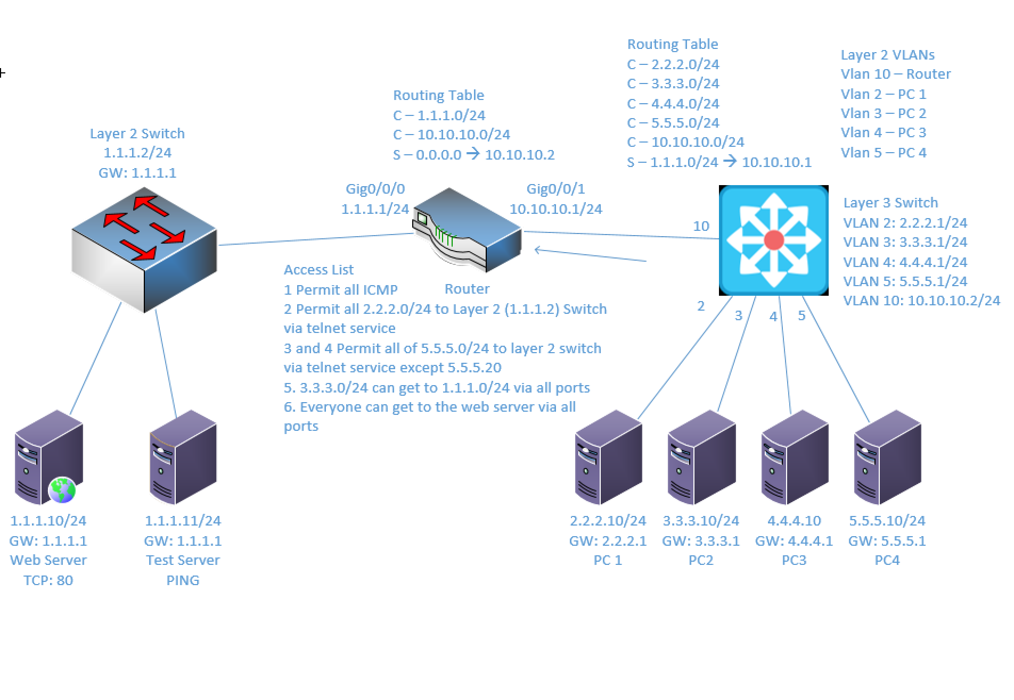
Components:
6 – PC’s with an Ethernet NIC
1 – Layer 3 Switch
1 – Layer 2 Switch
1 – 2 Port Router
Useful commands for this lab:
show ip route – view routing table
show vlan – View vlan table and port assignments
show ip interface brief – view status of layer 3 ports
show access-lists – view access lists and hit counters

Enable routing on Layer 3 switch
ip routing

Enable Telnet:
line vty 0 15
password telnetpassword – set telnet password
login – enable login process
access-class 10 in – apply access-list to vty (telnet)

Create standard ACL (1-99)

access-list 5 permit 7.7.7.0 0.0.0.255
access-list 5 permit 9.9.9.0 0.0.0.255

Create extended access-list

access-list 155 permit tcp 7.7.7.0 0.0.0.255 9.9.9.0 0.0.0.225 eq 23
access-list 155 permit tcp 7.7.7.0 0.0.0.255 9.9.9.0 0.0.0.225 eq 80

Apply ACL to router interface

interface gigabitethernet 0/0/1
ip access-group 155 in

Create Static route – All non-local traffic to 10.10.10.2

ip route 0.0.0.0 0.0.0.0 10.10.10.2

Procedure:
- Connect all PC’s together and put their static IP addresses, subnet masks and gateways on them. Test connectivity by pinging each machine within the network.

- Use the diagram to label the Layer 3 switches VLAN IP addresses and ports below.

Layer 3 Switch

VLAN | IP Address | Switch Port
2 | 2.2.2.1/24 | 1
3 | 3.3.3.1/24 | 2
4 | 4.4.4.1/24 | 3
5 | 5.5.5.1/24 | 4
10 | 10.10.10.2/24 | 24

- Use the diagram to label the routing tables for the Layer 3 switch and router below.

Router | Layer 3 Switch
C – 1.1.1.0/24 | C - 2.2.2.0/24
C – 10.10.10.0/24 | C - 3.3.3.0/24
S – 0.0.0.0 > 10.10.10.2 | C - 4.4.4.0/24
 | C - 5.5.5.0/24/
 | C - 10.10.10.0/24
 | S – 1.1.1.0/24 > 10.10.10.1

- Place the switch ports into the proper vlans. Configure all of the switches Layer 3 vlan IP addresses.
  - Example:
interface Gigabitethernet 1/0/1
switchport mode access
switchport access vlan 2
no shutdown
interface vlan 2
ip address 2.2.2.1 255.255.255.0
no shutdown

- Enable routing on the Layer 3 switch

  - What command did you enter?
Ip routing
- View the routing table on the Layer 3 switch

  - What command did you enter?
Show ip route

- Verify that the PC’s on the switch can ping each other

- Configure the IP addresses on the router interfaces and turn the interfaces on. Remember that router interfaces are shut down by default. You’ll need to do a “no shutdown” to turn them on.

- View the routing table on the Layer 3 switch

  - What command did you enter?
Show ip route

- Place the proper static route on the switch. Refer to the diagram above.

  - What command did you enter?
Ip route 1.1.1.0 255.255.255.0 10.10.10.1

- Place the proper static route on the router. Refer to the diagram above.

  - What command did you enter?
Ip route 0.0.0.0 0.0.0.0 10.10.10.2

- Verify all the PC’s can ping each other

- Place an enable password of netcom on the router.

  - Example:
enable password supersecretpassword

  - What command did you enter?
Enable password netcom

- Enable telnet on the router
  - Example:
line vty 0 15
password netcom
login

  - What commands did you enter?
Line vty 0 15
Password telnetpassword
Login

- Create a standard access-list on the router using a list number of 10. Allow access from the 1.1.1.0/24 and 2.2.2.0/24 networks.
  - Example: Don’t use the example 50 network. Use 1.1.1.0 and 2.2.2.0. The 50.50.50.0 is just an example.
access 10 permit 50.50.50.0 255.255.255.0

  - What access-list statements did you enter?
Access 10 permit 1.1.1.0 0.0.0.255
Access 10 permit 2.2.2.0 0.0.0.255

- Apply access-list 10 to telnet
Example:

line vty 0 15
access-class 10 in

  - What commands did you enter?
Line vty 0 15
Access-class 10 in

- Test telnet access from 1.1.1.10

  - Were you successful?
Yes
  - Why?
Because the access list allows telnet access from the 1 network.
- Test telnet access from 3.3.3.10. Remember, some tests are unsuccessful by design.

  - Were you successful?
No
  - Why?
The access list does not include network 3, and so it’s automatically dropped.
- View access list 10

  - What commands did you enter?
Show access-lists

  - Do you see any hits?
Yes
  - On which ACL lines?
ACL Line 10
  - Why?
Because this line corresponds to the 1 network and I used it to access the router via telnet.
  - Do you see any hits for denied traffic?
No
  - Why?
There is no rule set for the denied network, so it just got dropped.

- Enable telnet on the Layer 2 Switch and put an IP address on VLAN 1. Also configure a gateway
  - Example:
line vty 0 15
password netcom
login
interface vlan 1
no shutdown
ip address 1.1.1.2 255.255.255.0
ip default-gateway 1.1.1.1

- Create an extended access-list using a list number of 100.
  - Permit all ICMP traffic
  - The 2.2.2.0/24 network can get to 1.1.1.2 via tcp port 23
  - The 5.5.5.0/24 network can get to 1.1.1.2 via tcp port 23 except 5.5.5.20
  - The 3.3.3.0/24 network can get to 1.1.1.0/24 network via all protocols and ports
  - Everyone can get to 1.1.1.10 via tcp port 80
  - Create a rule to deny all other traffic

- What access-list statements did you enter?
Access-list 100 permit ICMP any any
Access-list 100 permit tcp 2.2.2.0 0.0.0.255 host 1.1.1.2 eq 23
Access-list 100 deny tcp host 5.5.5.20 host 1.1.1.2 eq 23
Access-list 100 permit tcp 5.5.5.0 0.0.0.255 host 1.1.1.2 eq 23
Access-list 100 permit ip 3.3.3.0 0.0.0.255 1.1.1.0 0.0.0.255
Access-list 100 permit tcp any host 1.1.1.10 eq 80
Access-list 100 deny ip any any

- Apply access-list 100 to the 10.10.10.1 interface for inbound traffic

  - What commands did you enter?
Int gi0/0/1
ip access-group 100 in

- Test telnet access to switch 1.1.1.2 from 2.2.2.10

  - Were you successful?
Yes
  - Why?
The ACL allows telnet access to 1.1.1.2 from the 2 network.
- Test telnet access to switch 1.1.1.2 from 3.3.3.10

  - Were you successful?
Yes
  - Why?
The ACL allows all network traffic to 1.1.1.2 from the 3 network.
- View access list 100

  - What commands did you enter?
Show access-lists

  - Do you see any hits? Yes

  - On which ACL lines?
The lines that we tested

  - Why?
Because the rules were applied to the traffic we directed
  - Do you see any hits for denied traffic?
Yes
  - Why?
There is a deny rule that we configured, so it is denying all other traffic.

- Draw the lab diagram below using either Visio or Packet Tracer. It should look similar to mine above but should NOT be a copy and paste of mine. Label the IP addresses, subnet masks, and gateways used by each device. Label the routing tables next to the switch and router and the switches vlan IP addresses and port vlan information. List the ACL statements next to the router for ACL 100 and ACL 20. If you use Packet Tracer, you can use the show commands for routing tables, access-lists, vlan tables, etc.

